PROJECT DESSERTATION

To start this project, I was using XAMP SERVER and to be open the path is localhost/Project_H2On/homepage.php#
In the Home page the links working apart GET A QUOTE link because basically I have to create a page.
All the other pages with I have create must be populate with same div class and become a proper page like the home page.
In the FEEDBACK page the feedback must be created with Excellent ,Good ,Not good or Bad and of course the page to be completed with same div and same text about the Feedback and at the same time to be created a external CSS for all the Pages except the Home Page because it is a template received from University.
The logo is this  and has be added on all pages like a link and when you click on it to be sent in HOME PAGE.
Please check the connection with the server as well and the database was called “ecommerce” like can be seen from the php script.

The PRODUCTS page is the most important and I with like to look on the connection with the server basically when I have introduced the products pictures on the database and I with like to choose one it is hive me errors.
On the page I with like to have a banner with the day offer with four pictures .
All the other products be added like a link and when you click on to be added on the cart and of course to the payment process.
All the pictures are on the pictures folder.

All the rest of the pages LOGIN,REGISTRATION,CONTACT US,REGISTER WEB MASTER, and LOGIN WEB MASTER has just to have a commercial face with logo in the each page and a Background colour same div and the CSS must be external.
I have attached a picture with the database.
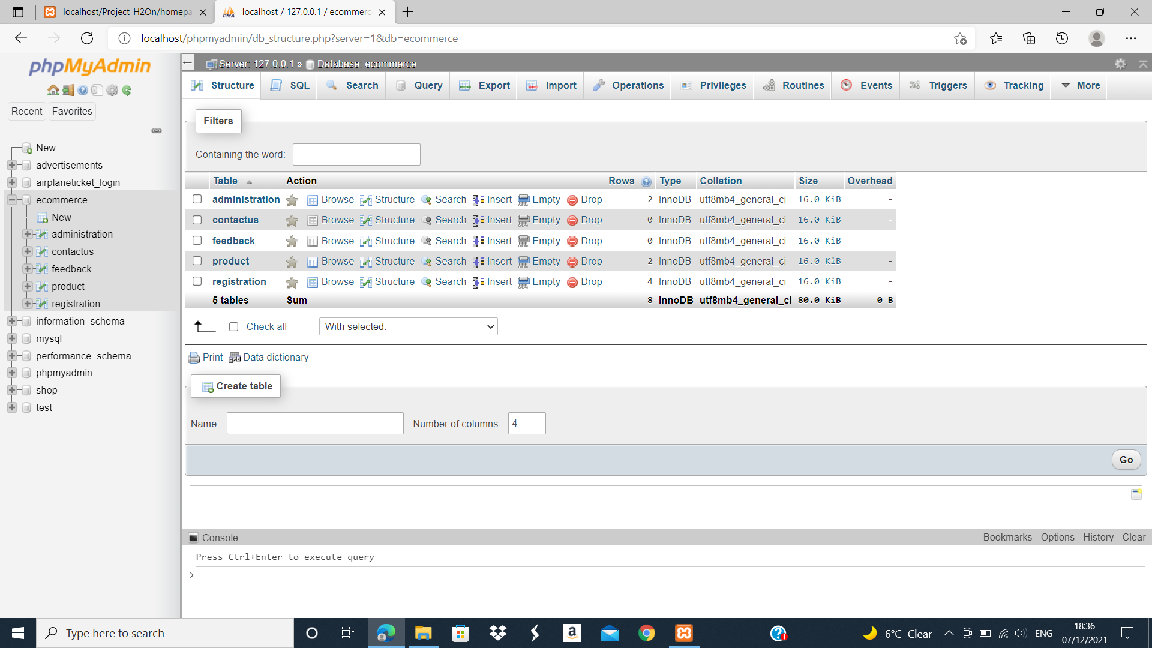

Web master password 1234 like in the pictures on Administration table.
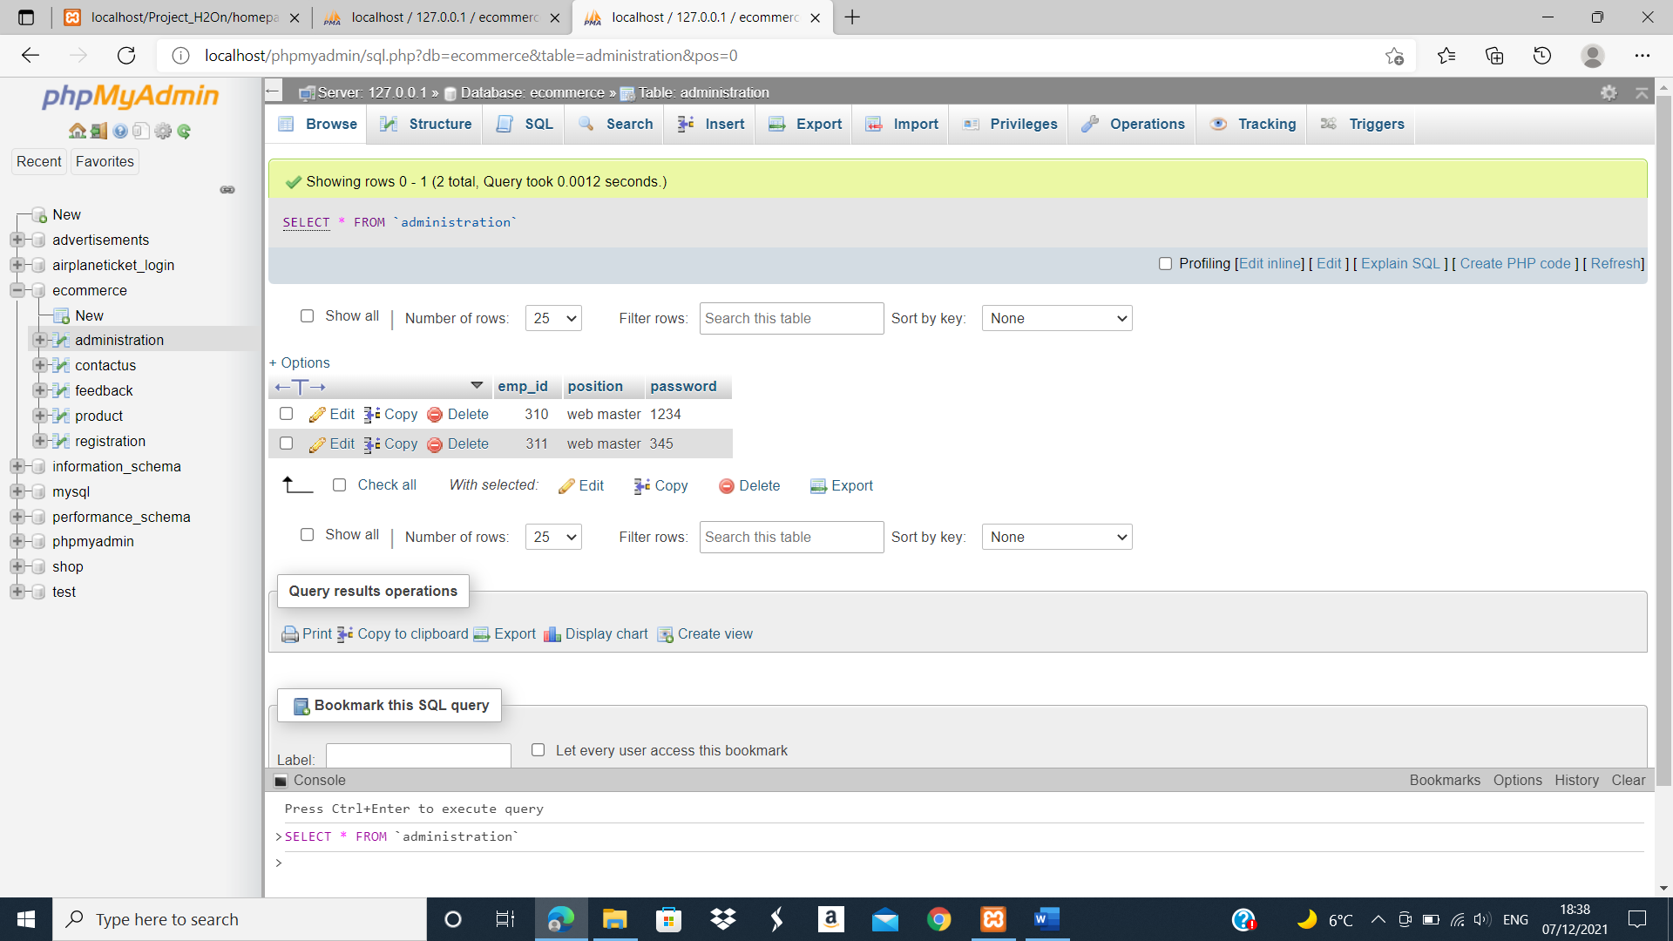

On the Product Table I have introduced 2 product pictures from picture folder to tray to pick then up on the web page but it doesn’t work so must be fixed.
For any other questions I am available Monday, Sunday and Saturday all day and Tuesday to Friday from 07:00 till 12:00 at phone nr 07405666854

